|  |  |  |  |
| --- | --- | --- | --- |
| Context | 2 | What we do?   * What achieved last year | 13/14 |
| Mission statement, Core values, Map and Introduction | 3-10 | What do we want to do next?   * Ambitions | 14/15-52 |
| The Planning Cycle | 11 | List of Achievements 23-24 | 53-61 |
| What is a Town Council | 12 | List of Achievements 22-23 | 62-69 |
| What can we do?   * Powers and Duties * Accountability | 12 | Review | 70 |

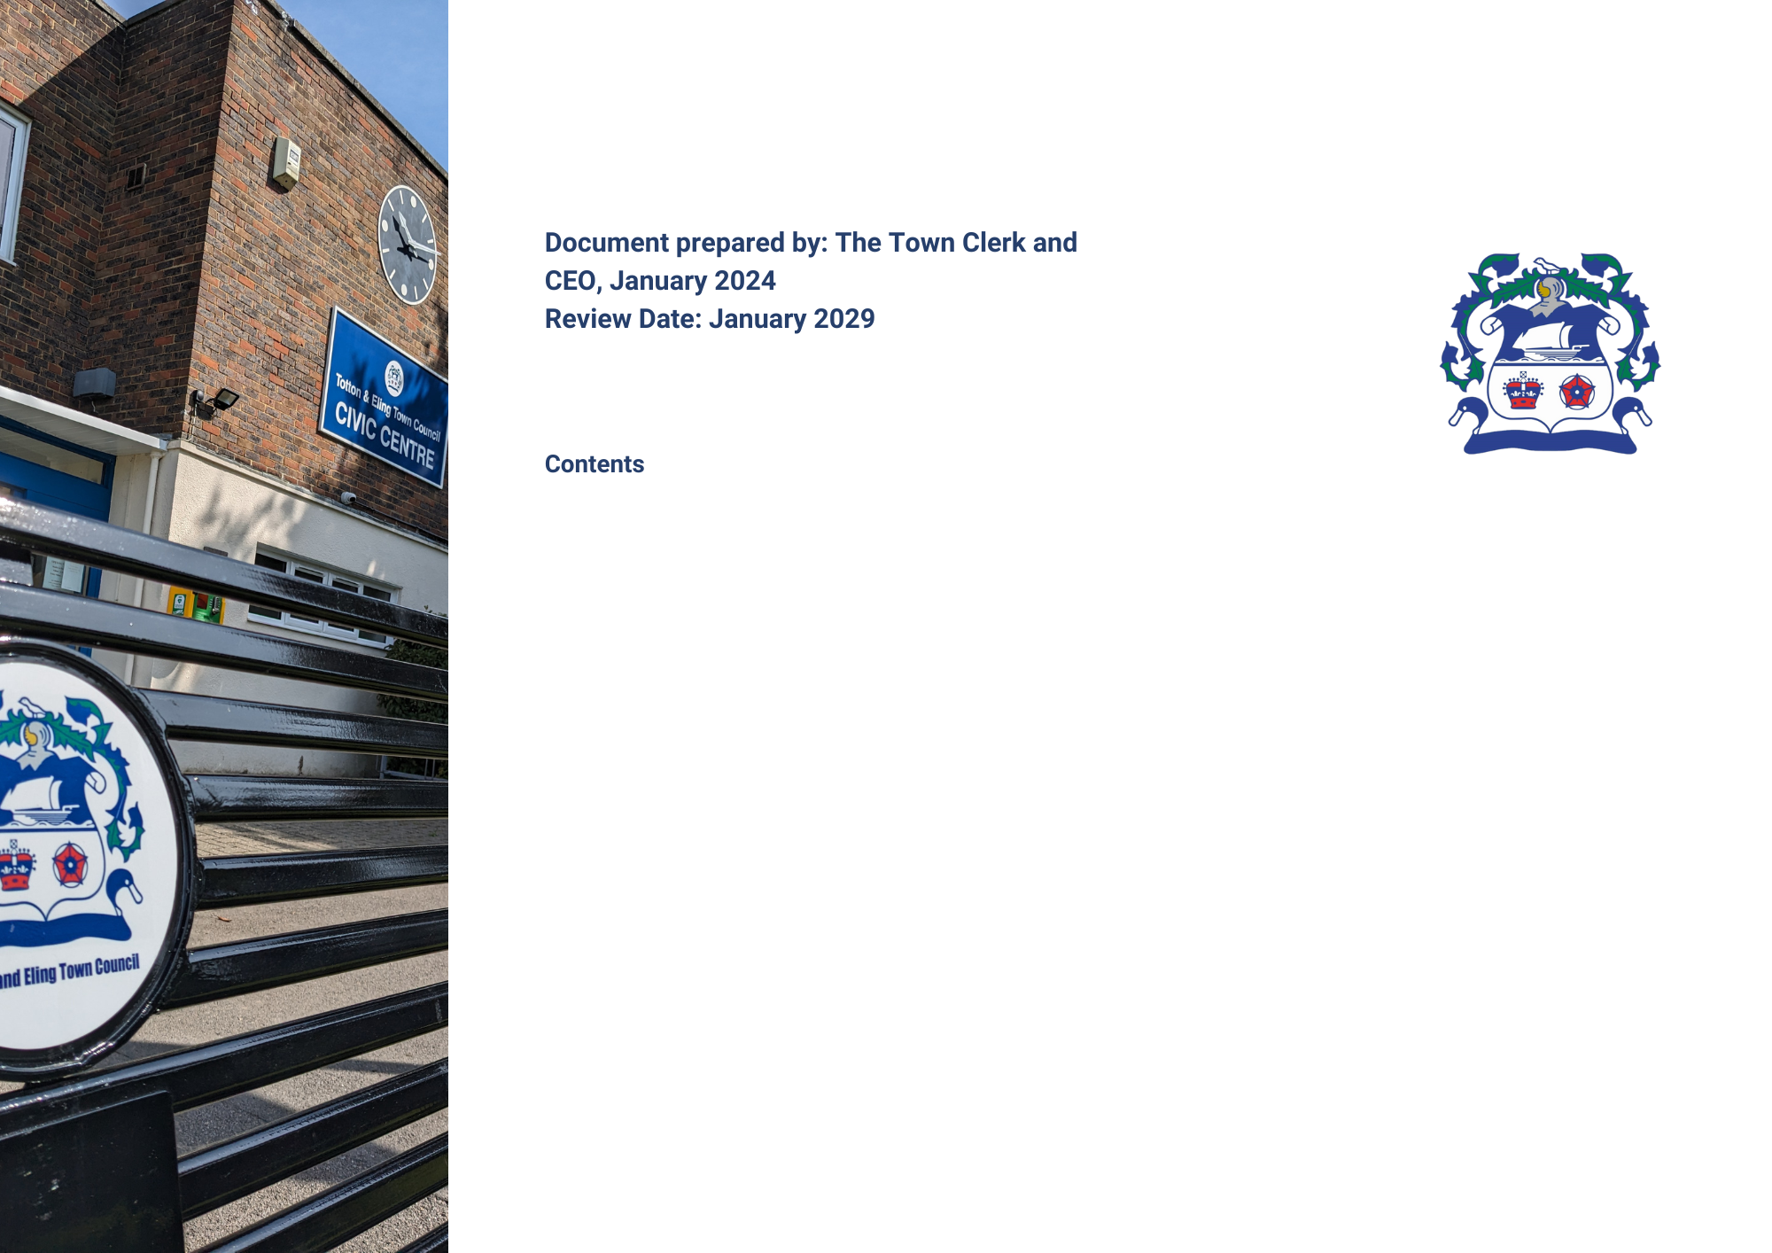

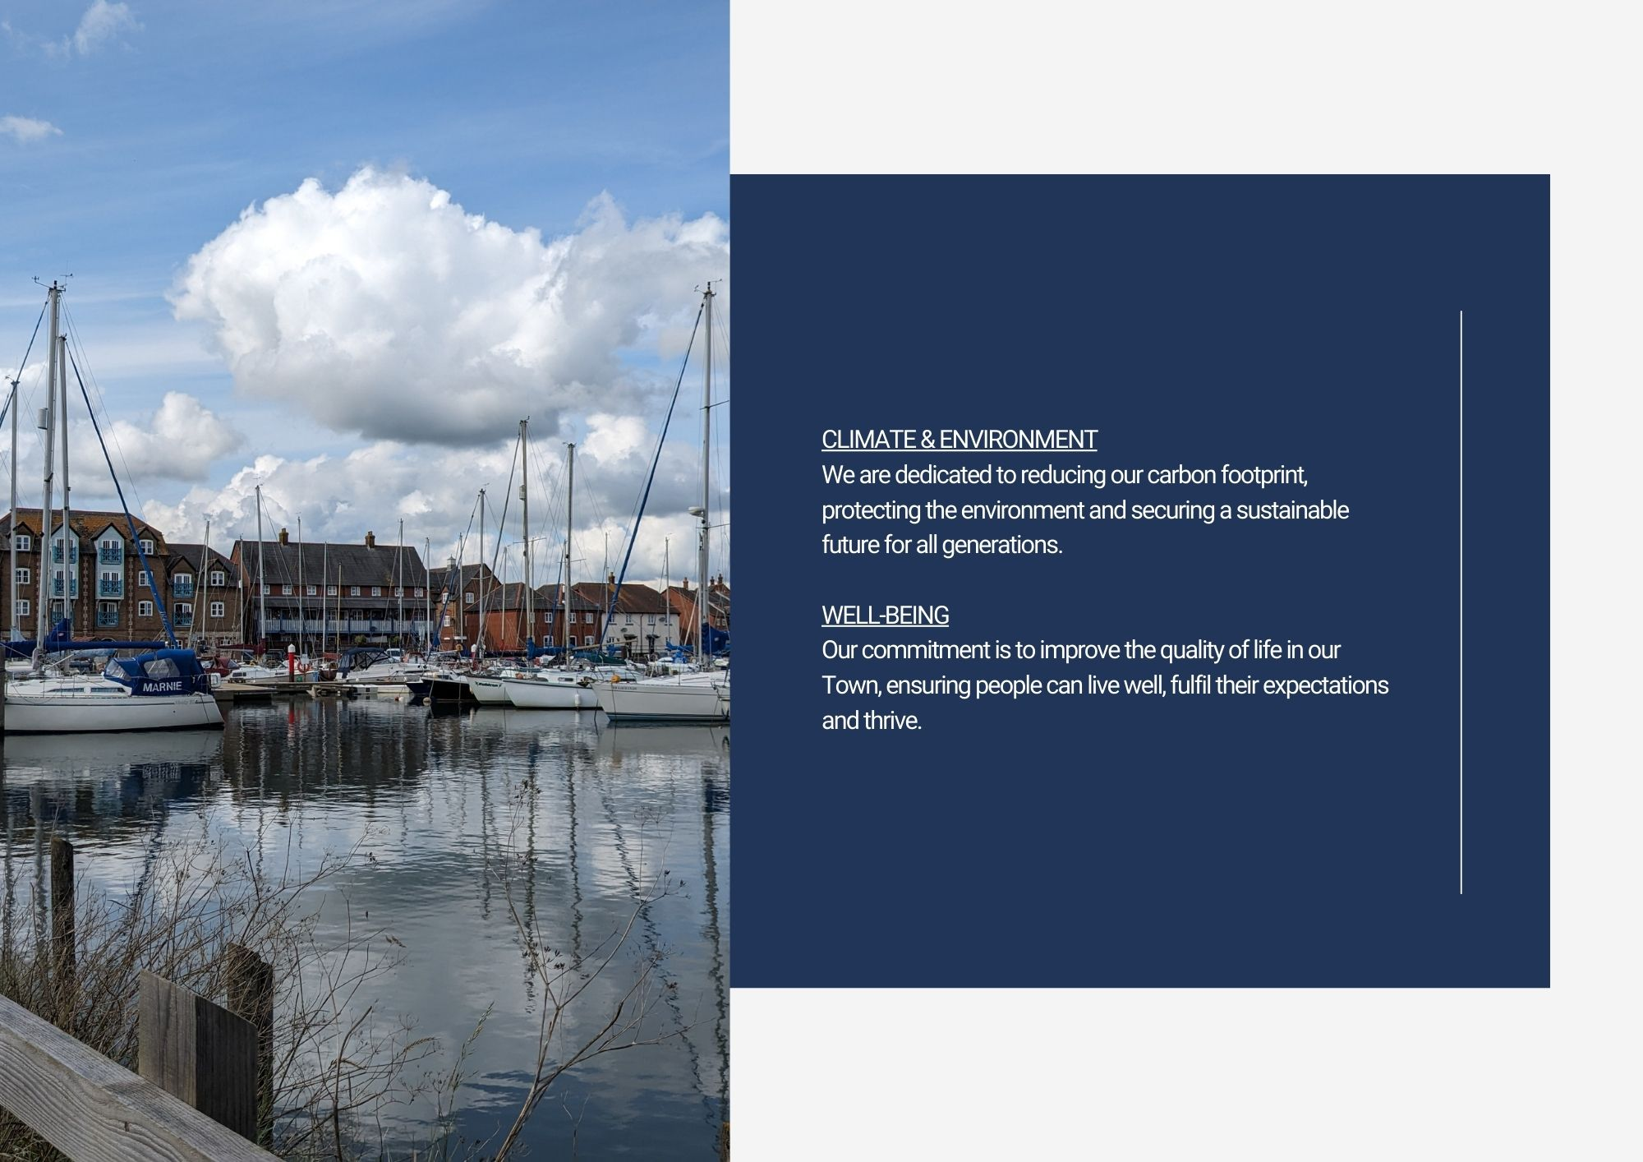

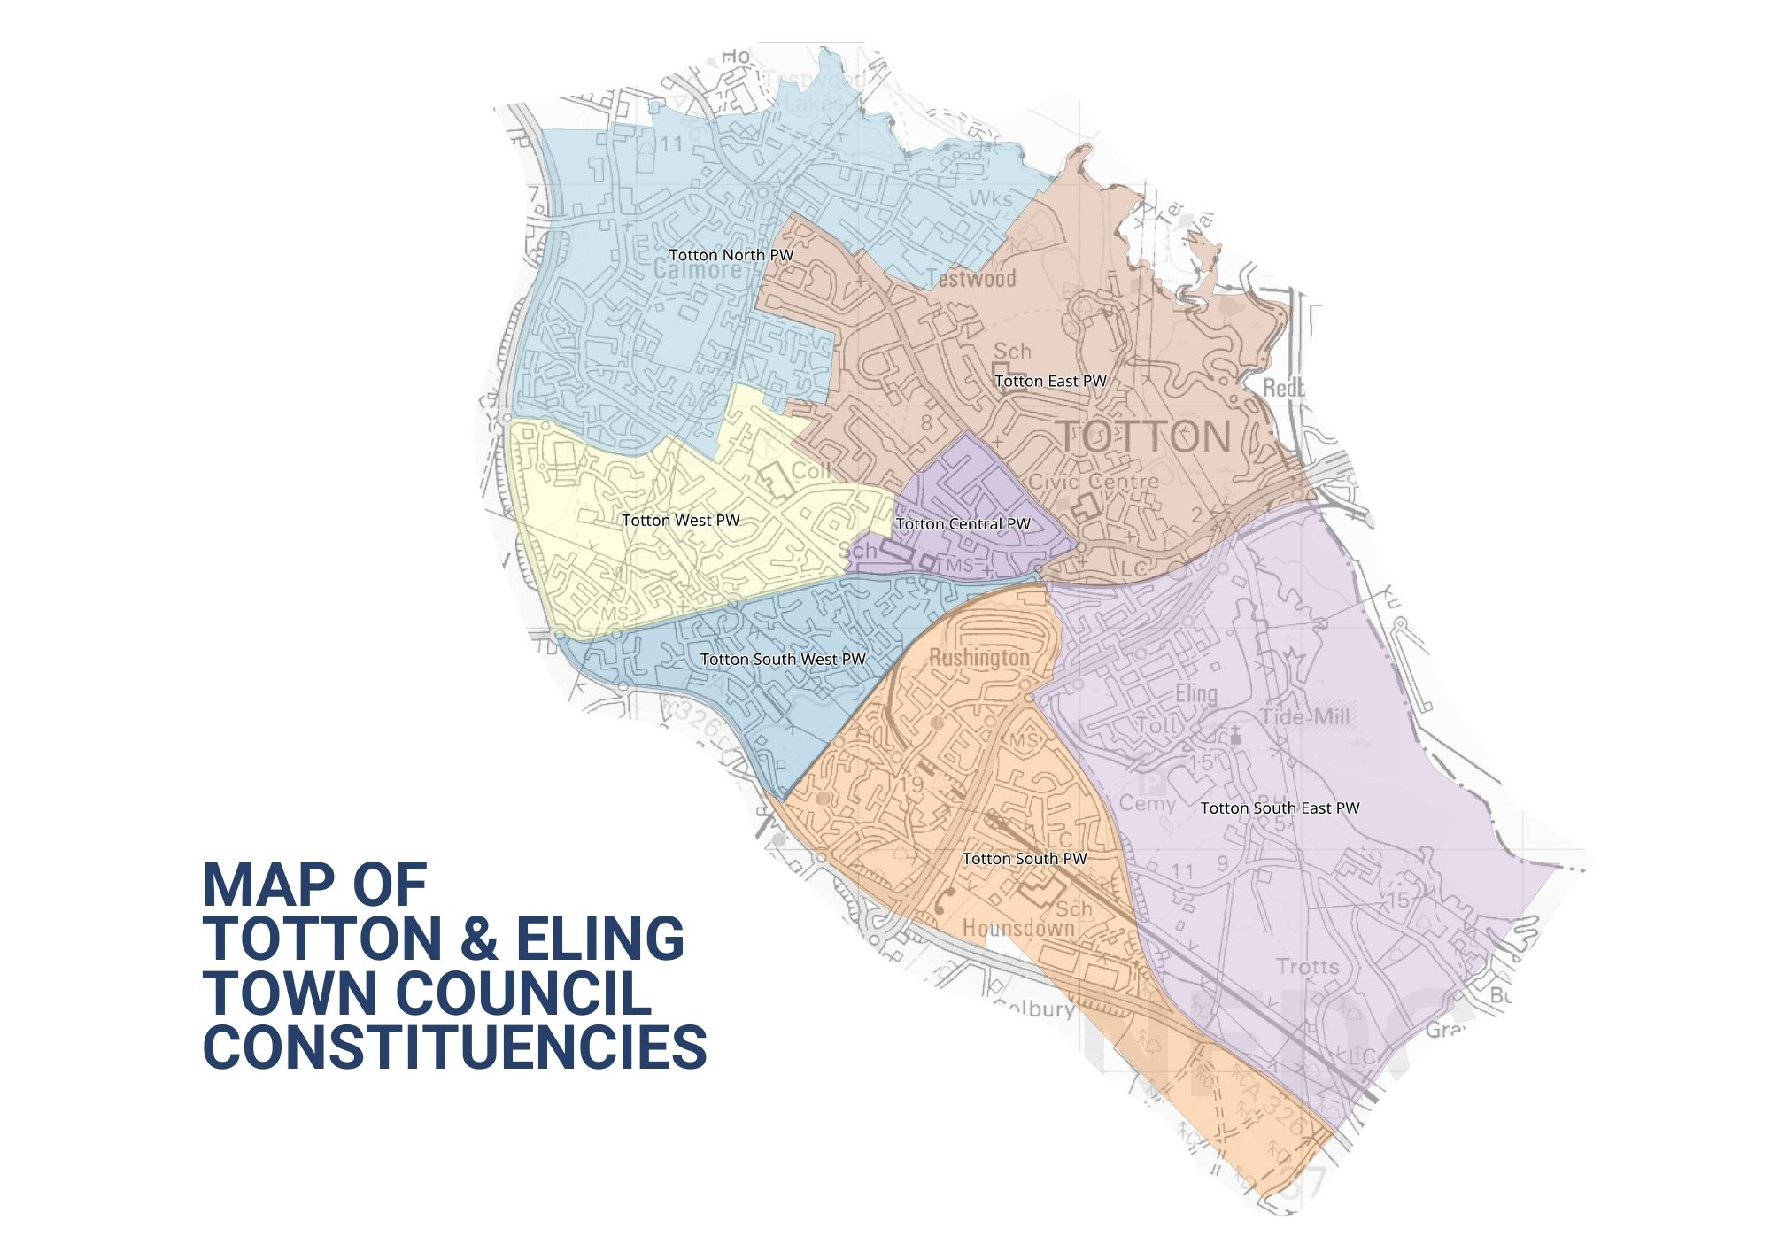

**Introduction**

Welcome to Totton and Eling Town Council. This is our Strategic Plan – it sets out what we are going to do over a rolling year period of five years and is a statement that we must be a Town Council that is relevant and responsible. The Plan takes into account the issues facing us and our ability to respond with the resources available. It makes clear there will be choices, and how the Council will decide which to prioritise.

The Plan has been approved by your Town Councillors. It is essentially a planning tool to assist us with the practical decisions we have to take when we meet bi-monthly, supported by a review process that helps us look back on our performance. By publishing our Strategic Plan, we can help those who live, work or visit the Town see what we are doing on their behalf. The Council has devised pillars or themes that will be referred to in the plan and will form the basis for the Council’s strategic aims and will comply with its code of conduct and Nolan principles, which include selflessness, integrity, objectivity, accountability, openness, honesty and leadership.

**Context**

This is our first Strategic Plan, prepared at a time of austerity across society when all organisations that provide services to the community, be they public, private or voluntary are facing cost pressures and resource restrictions. The emphasis is on value for money, efficiencies, collaboration and accepting that some things just will not get done. Through a planning process though, we can have a shared vision and direction, protect what is important and consider new ways of implementing progress. The ambitions and projects included in this plan have been approved, in principle, by the Council as areas to support and resource. All projects/ambitions, which the Council feel best meet with local needs and priorities, will be kept under review and will be amended and updated as circumstances change. The Town Council have recognised the importance of establishing a Mission statement, and set of core values, which are reflected in the plan, and which are at the heart of how we operate and conduct Council business.

Totton and Eling Town Council, as the first tier of Local Government, is uniquely situated to provide the forum for understanding and supporting the needs of this community.

It provides advocacy on behalf of its residents, uses linkages to other organisations to bring in services, or directly procures them itself. Liaison with New Forest District Council happens at all levels, and there are also association to health and social care as well.

Day-to-day, the Council will seek solutions for the community, looking for skills and volunteers to make improvements to our surroundings or bringing particular neighbourhood issues to local attention to promote a better quality of life for all.

Above all your Town Council is here to help, support and encourage. This Plan tells you how.

**The Planning Cycle**

Planning (and performance) is a continuous process of gathering and assessing information, formulating actions, *doing them*, and then reviewing performance and gathering again.

Once specific actions are agreed to deliver this Plan, they are entered on the Actions/Task Register, which is monitored at every weekly meeting by the Town Council’s Senior Leadership Team and also at monthly meetings held with the Committees Chairs.

**Association**

This plan is linked very closely to the allocation of resources – mostly financial, but people’s time and energy too. Our finance is mostly derived from the Council Tax system, which follows the financial year April to March. Our precept, or ‘demand’, placed upon the Council Tax system has to be declared by January each year, in order that New Forest District Council can calculate the overall tax collection sums for each eligible household and produce the billing required. Other income is sourced through service provision.

**Key dates**

Therefore, this Plan will be monitored and updated, allowing it to evolve as the budget is also prepared, for final precept calculations in November. The Plan cycle will run from April to March, to match the funding available, and will be reviewed at monthly Chairs of Committee and Senior Management Team meetings to assess achievements in the previous cycle, and progress in the current one.

**What is a Town Council?**

A civil Town or Parish is an independent local democratic unit for villages, Towns, and suburbs or urban areas. Each Town/Parish has a Parish (or Town) meeting consisting of all its local government electors and most (where the electorate exceeds 200) have a Parish or Town Council. Over 13 million people live in such parishes, with approximately 30,000 in the Town of Totton and Eling. The Town Council is supported by Officers employed within each service area to deliver both the Council’s services and policies, together with ensuring decisions are implemented appropriately.

The Town Council is a local authority. Its Councillors are elected for four years at a time in the same way as for other Councils. Bye-elections may be held to fill vacancies occurring between elections, or members may be co-opted onto the Council if no election is called. The Council is the corporation of its Town in the New Forest area, it covers the Town of Totton and Eling. In May each year the Councillors choose a Chairperson and Vice Chairperson from amongst their number. In Totton and Eling, there are 20 Councillors who make up the Town Council, which employs a Clerk to manage administration and the day-to-day running of the Council and its facilities. The Town Council will adhere to good governance and best practice via its adopted and published policies/procedures and act in the interests of local people in making representation.

**What can we do?**

**Powers and Duties**

Town Councils have a number of formal powers, set out in a wide range of legislation. A duty is something that a Council must do, a power is something that it may do, if it so decides. A Town Council cannot do anything that is not permitted by law.

The Town Councillors know the Town and can now (and increasingly often do) represent their views directly to other authorities like the District and County Council at its Area Boards, Health Authorities, Police and Fire Authorities meetings.

They are entitled to be consulted on planning applications, which include work to listed buildings and on proposals in conservation areas and are often consulted on such things as schools and roads. They put the Town’s case at public inquiries.

There is the power to create a Neighbourhood Plan which allows local people to get the right development for their community, but the plans must still meet the needs of the wider area.

**Accountability**

You elect its members every four years – the next time will be May 2027 – and you are entitled to attend the Annual Town meeting between March and June each year and to say what you think. You can also go to every meeting of the Town Council and meet the Council members, listen to their business, and participate during the time especially set aside for that purpose at the start. The accounts are strictly audited every year and published.

You can find out more about what we do, how we do it, and our meetings on the Town’s website at <http://www.tottoneling-tc.gov.uk>

**What do we do?**

The Town Council provides a number of direct services to the community and acts as custodian to a number of assets held in the ‘public name’ and provide the following services:

Allotments Parks & Open Spaces Outdoor paddling pools and splash park Leisure & sports facilities

Halls for Hire Public conveniences Memorials Public notice boards

Boat moorings Bus shelters Community safety warden Heritage site and café

Skate park Cycle track Town benches Walking routes

Although New Forest District Council is the Planning Authority, the Town Council is consulted on each planning application made in the Town. Councillors consider planning applications at their meetings and inform New Forest District Council of their views and recommendations.

At each meeting of the Council, reports from a variety of Town organisations are received, and Councillors seek to provide support where necessary or requested in order that local groups can continue to thrive.

Each meeting considers issues for our communities such as planning (for example, housing, change of use or tree felling) crime and community safety, facilities for all generations, or items of maintenance in the ‘public realm’ that need reporting to appropriate authorities. The Council can act as advocate for residents, a conduit for communicating information, and will liaise with appropriate departments of other public authorities to ensure that views, comments and necessary actions are dealt with.

**What we achieved in the last year**

Between 2022 and 2023, we have achieved a wide range of improvements, both to the way we work, and to the community we serve. These are listed later in this document.

**Established** policy reviews and formulation such as Equal Opportunity, Members and Officers Best Practice, Annual Leave and a General Reserves Policy are but a few actioned during 2022/23.

**Considered:** planning applications, grant applications, activities, events, legislation, projects, most of which were supported by the Council together with policies and procedures.

**What do we want to do next?**

The Town Council has worked through the Town’s Committees and Group’s findings and has developed a 5-year Strategic Plan. This plan has been built around our Mission Statement, Core Values and public consultation. As a live document it will be expanded and evolved as it develops.

The table attached sets out the Strategic Plan adopted by the Council, and which will be implemented over the next five years:

**5 YEAR PLAN**

|  |
| --- |
| **WELLBEING, HEALTH & SAFETY – Supporting life satisfaction, achievement and security.** |

|  |  |  |  |  |
| --- | --- | --- | --- | --- |
| **Ambition** | **Council Committee/**  **Department** | **Timescale** | **Success would be** | **Progress At:**  **29/08/24** |
| **Formulation of a Youth Council** | Wellbeing Group  Policy & Resources Committee | 0 – 1 year | To implement and support a well-attended Youth Council, encouraging good communications with the Council and for young people to take part in the democratic governance of the Town. | Approval given and Councillors were appointed at Full Council on 31.07.24, to converse with school Councils to gain young people’s input on projects and activities in the Town. Proposed first school visit scheduled for September 2024. On-going. |
| **Resident’s Forum** | Wellbeing Group  Policy & Resources Committee | 0 – 1 year | Giving residents a voice and allowing them to advise the Council of issues, and requests. Additionally, providing feedback to the public, will enhance communication, confidence and thus provide a better place to live and work. | Update from meeting in April 2024 verified that existing Residents’ Associations already have strong Council liaisons. Recommendations for a residents’ evening event have now been cancelled due to lack of support. On-going |
| **Business Forum** | Town Clerk  Wellbeing Group | 0 – 1 year | Forming a business forum will provide support to the businesses in the Town giving the opportunity for input and thus encouraging a thriving community. | Two meetings have been held resulting in some positive feed back. A business forum social media page is being investigated. The last meeting held in May was not attended by any businesses in the Town. |
| **Follow and review Town Council’s Health & Safety Policy** | Policy & Resources Committee | 0 – 5 years | Ensure the Town Council provide a legal, safe, and secure working environment for staff, Councillors, volunteers and service users. | Health & Safety annual audit was completed in March 2024. Policy was renewed in March 2024. Next due for renewal March 2025.  On-going |
| **Health & Safety/Fire training for staff** | Town Clerk  HR Department | 0 – 5 years | Recognising the importance of training being given to staff for their safety and wellbeing. | On-going H & S/Fire training courses organised for all staff. Fire drills are held on a 6 monthly basis. |
| **Expand CCTV coverage of the Town** | Amenities Committee, Policy & Resources Committee | 0 – 5 years | Provide a safer environment by supporting anti-crime and disorder within the Town, giving residents, visitors and businesses a sense of security and peace of mind. | Additional cameras in areas of the Town are being considered.  Awaiting response on feasibility studies on suggested areas. |
| **Uphold diversity, equality and inclusion within the Town** | Policy & Resources Committee | 0 – 5 years | By the introduction of improved facilities and open spaces the Town Council would reiterate and develop its commitment to working towards all individuals making use of those facilities in line with health & safety, legislation and inclusion. | Funding for this play equipment will be from CIL monies, and appropriate inclusive equipment is being sought. |
|  |  |  |  |  |
| **IT, COMMUNICATIONS & MARKETING – Building trust, confidence and success through strengthened communication.** | | | | |

|  |  |  |  |  |
| --- | --- | --- | --- | --- |
| **Ambition** | **Council Committee/**  **Department** | **Timescale** | **Success would be** | **Progress At:**  **29/08/24** |
| **Digital play area, tree, and allotment inspections** | IT, Communications & Marketing Task & Finish Group  IT Officer | 0 – 1 year | More accurate and detailed digital inspections, would assist in identifying insurance liability responsibility, an improved Health & Safety focus and the implementation of preventative measures. | Equipment and software are presently being researched.  On-going |
| **To encourage residents to have their say, and provide input and feedback to the Council via our website and social media pages** | IT, Communications & Marketing Group.  IT Officer. | 0 – 5 years | Improvement of public participation in decision making and ideas/suggestions for facility provision and improvements for the Town. | Part of the Council’s IT improvements.  On-going |
| **Support and increase the range of information available to residents in relation to community projects, activities and services.** | IT, Communications & Marketing Group  IT Officer | 0 – 5 years | Improvement of communication channels to provide the community with up to date, and accurate information for the betterment of wellbeing, business and civic pride. | Part of the Council’s IT improvements. Links to support and aid groups will be incorporated into the new website for maximum awareness of what is on offer for residents. Groups are being added as part of the expansion of the new website.  On-going |
| **Identification of IT opportunities** | IT, Communications & Marketing Group  IT Officer | 0 – 5 years | By monitoring and identifying up and coming IT this will enable reform and more efficient staff and Councillor operation. | Upgrades of CPU’s at the Civic Centre are required for new windows package, by October 2025 when the support for the present package ends. Costs will be evaluated via the tendering process. On-going. |

|  |
| --- |
| **POLICY – Assurance of compliance, best practice and values.** |

|  |  |  |  |  |
| --- | --- | --- | --- | --- |
| **Ambition** | **Council Committee/**  **Department** | **Timescale** | **Success would be** | **Progress At:**  **29/08/24** |
| **Review of fit for purpose Standing Orders, and Financial Regulations** | Policy & Resources Committee  Town Clerk | 0- 2 years | Updated, more defined and inclusive standing orders for improved governance and policy adherence. | Commencement on the standing orders review is underway and good progress is being made.  On-going |
| **Review of Byelaws** | Policy & Resources Committee  public consultation, government bodies  Town Clerk | 0 – 3 years | Reformed byelaws more relevant to the provision in the Town. Improved governance and byelaw adherence. | Anticipate commencement in Summer 2025.  On-going |
| **Press & Media Policy**  **Dispensation Policy** | Policy & Resources Committee  Town Clerk  IT, Communications Officer  Policy & Resources Committee  Town Clerk | 0 – 1 year | Formulation of a Press & Media Policy will define transparency and the communications process from the Council.  This policy will ensure the Town Council acts accordingly with the localism act 2011 and will interpret the procedure of both Councillor dispensation application and award. | Policy is on the Policy & Resources agenda for September 2024.  On-going.  Policy is on the Policy & Resources agenda for September 2024.  .  On-going |
| **On-going staff structure review.** | Town Clerk  Personnel Sub Committee (if applicable) | 0-5 years | Periodic review to ensure staffing structure meets business needs and requirements. | Monitoring and assessment in progress.  On-going |

|  |
| --- |
| **HERITAGE, ARTS & CULTURE – preserving heritage and culture, together with Town creativity and identity.** |

|  |  |  |  |  |
| --- | --- | --- | --- | --- |
| **Ambition** | **Council Committee/**  **Department** | **Timescale** | **Success would be** | **Progress At:**  **29/08/24** |
| **Bollard painting** | Amenities Committee | 0 – 2 years | Providing individualisation and making the Town more attractive and welcoming for both residents and visitors. | War memorial bollards have already been completed. Further bollard decoration estimated throughout 2024.  On-going |
| **Provide support for arts, cultural events and activities in the Town** | Amenities Committee Policy & Resources Committee  IT Officer | 0 – 5 years | Bringing cultural/artistic awareness and education to the Town. Increasing footfall relating to events, businesses and Town facilities for communal utilisation and enjoyment. | Consideration for support of art and cultural event requests are regularly received and are welcomed by the Council.  On-going |
| **Provide Amenities for Arts and cultural performance** | Amenities Committee | 0 - 5 years | Continuance of the leasing of the Council’s Hanger Farm facility and introduction of a performance area in the Town Park, will uphold and expand the Communities’ exposure to, and enjoyment of, Arts and Culture in the Town. | Continuance of support for Arts and Cultural performance is through the Hanger Farm Arts Centre, via Arts Festival aid and promotion of this stunning facility.  Meetings with Hanger Farm Arts Centre are held on a 6 monthly basis.  On-going |
| **Support continuation and improvement of the Eling Tide Mill Experience and to promote local historical interest** | Amenities Committee | 0 – 5 years | The Council’s preservation, support and funding of this prime heritage site will ensure the provision to local residents and visitors offering the continued opportunity to enjoy this unique historical site. | The Tide Mill is undergoing repairs. The café and visitors centre are now open for 5 days per week during the winter months and events and funding are being applied to the experience as a whole throughout the year to encourage more visitors to this worthy venue. Meetings are being held with landlord in relation to improvements to Eling slipway area.  On-going |

|  |
| --- |
| **INFRASTRUCTURE – Striving for improved accessibility, enabling better community interaction.** |

|  |  |  |  |  |
| --- | --- | --- | --- | --- |
| **Ambition** | **Council Committee/**  **Department** | **Timescale** | **Success would be** | **Progress At:**  **29/08/24** |
| **Better Road infrastructure in the Town Centre, with**  **more accessibility for cyclists and walkers** | Planning Committee | 0 – 5 years | The Council wish to instigate a walking & cycling transformation in the Town Centre which would allow better access, numerous health benefits, greener travel and road safety; subsequently promoting increased wellbeing and equity. | The Town Council are liaising with the County and District Council formulating a partnership which will progress the reform of the Town Centre infrastructure. A further meeting was held in July to discuss the formulation of a masterplan framework which was presented at Full Council on 31.07.24. Next meeting is scheduled for October. 2024.  On-going |
| **Better access to public transport** | Planning Committee | 0 – 5 years | Better public transport would provide people with access to essential services, employment and improved social integration. Additionally, it will reduce congestion and air pollution and offer a more affordable transport option. | The Council have an objective to work toward increasing the public transport in the Town to develop better quality community and equitable mobility.  On-going |
| **Increased and improved long term free parking in the Town** | Planning Committee | 0 – 5 years | More available long term free parking would produce increased foot traffic, a strengthened local economy, together with attracting more visitors and improved accessibility to public services, recreational facilities and health care. | The Planning Committee are examining options to improve the long-term free parking in the Town, which will not only improve the versatility of parking choices but assist in eliminating on-street parking issues for residents. Work is proceeding with the District Council for assistance in delivering better parking. A letter of objection to the increased parking and parking clock charges was sent to NFDC from the Town Council in December 2023. A petition from residents objecting to the parking fees/clock charges has been collated and was sent to the District Council for consideration in mid- February 2024. The District Council have advised that there are no plans to review the increase in charges.  On-going |

|  |
| --- |
| **GOVERNANCE, VISION AND STRATEGY – allowing evolved suggestion, inspiration, and measure of success.** |

|  |  |  |  |  |
| --- | --- | --- | --- | --- |
| **Ambition** | **Council Committee/**  **Department** | **Timescale** | **Success would be** | **Progress At:**  **29/08/24** |
| **Digital recording of meetings** | IT, Communications & Marketing Group  IT, Communications and Marketing Officer | 0-2 years | Digital recording of meetings will enable better transparency and improved community involvement in the Council’s governance. | The Town Council approved a Recording, Photography and use of Social Media at Meetings policy in September 2023. Progression to visual meeting recordings is in incorporated in the Council’s IT improvements.  On-going |
| **Improve the image of and pride within the Town, making it more attractive for residents, visitors and businesses** | Communications & Marketing Group Amenities Committee | 0 – 5 years | Ensuring a more positive image and individual character will help us reinvent the Town and boost retail, leisure and events for community participation. Town pride provides community focus and is a critical part of communal betterment of welfare. | The Town Council have formulated a Wellbeing group which is centred on improvement of Town pride, thus encouraging volunteers and groups to support activities for the common good of the Town’s population. Budgets and intensity of planting in the Town has increased, and plans for a community health bus are being discussed between local parish/town Councils, but will be dependent on obtaining funding.  On-going |
| **Continue to improve relationships between Councillors and Officers** | Town Clerk | 0 – 5 years | Improved communication between both Officers and Councillors will enhance unity in both the decision making and day-to-day running of the Council services, together with more effective communication to the community. | Monthly meetings with the Chairs of Committees and Senior Management occur where discussion permits communication and builds positive relationship between Officers and Councillors. This in turn aids the monitoring of projects, their deliverance and best value application.  Regular meetings of Officers and Councillors are organised throughout the year.  On-going |
| **On-going staff structure review** | Town Clerk  Personnel Sub committee (if applicable) | 0-5 years | Periodic review to ensure staffing structure meets business needs and requirements. | Weekly meetings of the Senior Leadership Team assess workloads and monitor performance to establish sufficient staffing levels. Relevant role evaluations are implemented, as required.  Some job evaluations required after recent annual appraisals. Commencing in late May 2024. Evaluations have now been completed.  On-going |
| **Ensure adequate level of insurance for Town Council facilities and assets** | Town Clerk  RFO | 0 – 5 years | Annual review of facility and asset insurance, together with public liability and indemnity will ensure the Council is adequately insured against claim, damage or obligation. | Regular reviews and stringent monitoring of claims and asset values  assure sufficient cover is in place at all times. Best value quotes are sought at time of renewal. Renewal of insurance has now been approved for 3 years.  On-going |
| **Development of a Neighbourhood Plan** | Planning Committee | 0-2 years | The Town’s Neighbourhood Plan is almost complete and is in preparation for consultation. The Neighbourhood Plan has given, and offers, further opportunities for residents to have a voice in the future of the Town for inclusion; this also portrays the importance of local needs and desires. Completion of the plan will also allow increased funding payable to the Council in regard to CIL monies from 15% to 25%. | Regular meetings have been held to progress the Neighbourhood Plan further and enquiries into drafting the plan ready for submittal to the District Council are imminent. Finalisation of the brief for the draft document was presented to Planning Committee in June 2024, and the tendering process will commence in August 2024. |

|  |
| --- |
| **PLANNING – Empowering community views and the development of our Town.** |

|  |  |  |  |  |
| --- | --- | --- | --- | --- |
| **Ambition** | **Council Committee/**  **Department** | **Timescale** | **Success would be** | **Progress At:**  **29/08/24** |
| **Planning applications consideration** | Planning Committee | 0 – 5 years | Although the Town Council is not the planning authority, deliberation and the opportunity to provide local views and reflections is paramount. These permit the projection of the communities’ thoughts, opinions and goals for what is being built, converted or situated in our Town. | Applications are considered by the Planning Committee on the first Wednesday of every month. Meeting dates are published on the Town Council’s website for attendance. An amendment to Section D, 4.3 of the planning delegation was approved and recommended at the Policy & Resources Committee meeting on 17th July 2024. |

|  |
| --- |
| **EVENTS – Building a sense of community spirit, social interaction and celebration of what is good in the Town.** |

|  |  |  |  |  |
| --- | --- | --- | --- | --- |
| **Ambition** | **Council Committee/**  **Department** | **Timescale** | **Success would be** | **Progress At:**  **29/08/24** |
| **Introduction of Town Market** | The Town Council | 0 – 1 year | By introducing a Town market this will provide the capacity to revitalise the Town and act as a communal pillar fostering community spirit and produce a unique local business experience. | Funding approved to commence this event. A Market Management company has been engaged and preparations are now under way for the second market date in September, with the first market having been held in August 2024. This proved to be very successful. It is envisaged that expansion of the market will be on-going through promotion of the market to both residents and stall holders. All market dates can be viewed on the council’s website.  On-going |
| **Continual support of Remembrance Day and Armistice Day** | The Town Council | 0 – 5 years | The continuation and importance of these popular and well attended events which give the Town the opportunity to pay tribute to the people who made sacrifices in times of war, is paramount. Assistance in funding these events is an honourable, respectful and significant commitment of the Town Council and a provision for this and future generations. | The Town Council provide funding for both the Remembrance Day and Armistice Day events and have budgeted to do so for the forthcoming year.  Amendments to the improvements to the War Memorial have commenced and are due to be completed by November 2024. Enquiries are being made in regard to possible VE celebrationery events.  On-going |
| **To encourage community initiatives to use the Towns facilities to create events, festivals, fetes, exhibitions, pop-up businesses and groups** | Amenities Committee  IT, Communications & Marketing Group | 0- 5 years | Provision of more events in the Town to promote improved wellbeing, social interaction and higher footfall to the Town area for businesses. | The Town Council annually license their land for events such as the Donkey Derby, Carnival, Fundays and sporting events. The Town Council will continue to make their land accessible for community events and consideration of all events are welcomed and supported wherever possible. The Donkey Derby has proven to be successful once again, as too was the Carnival.  On-going |
| **Create and manage an events page on the Town Council’s website** | IT, Communications & Marketing group.  IT Officer | 0 – 5 years | To attract larger numbers of people to support events within the Town and tackle social isolation. | Community events will be integrated onto our events page of the new website. This will improve awareness and promote involvement. This page is part of the expansion to the new website which was launched in April 2024. Events are published on the new web site regularly.  On-going |
| **To assist and support the Twinning Association with the Town twinning of Trittau in Germany and Communaute de Communes Loire Divatte in France.** | Town Council | 0 – 5 years | The Town Council wish to continue twinning with Trittau in Germany and Communaute de Communes Loire Divatte in France to further enable the formation of cultural and social links. It recognises the importance of association between two similar communities which, through exchange visits, builds relationships and educates in regard to other traditional lifestyles. | On-going support for the Twinning Association will ensure the continuity of good relations and ties with Totton & Eling Town Council, Trittau in Germany and Communaute de Communes Loire Divatte in France. A trip to Communaute de Communes Loire Divatte is planned for June 2024.  Additionally, 18 visitors from Trittau in Germany will arrive in Totton on Thursday 22 August, for a 5 day visit to the Town.  On-going |
| **FINANCIAL – Managing the Council’s finances through best value and transparency, thus successfully funding the resources needed to provide local public services.** | | | | |

|  |  |  |  |  |
| --- | --- | --- | --- | --- |
| **Ambition** | **Council Committee/**  **Department** | **Timescale** | **Success would be** | **Progress At:**  **29/08/24** |
| **Continue to comply with legislation to ensure the provision of accurate accounts and records** | Policy & Resources Committee  Responsible Finance Officer | 0 – 5 years | By ensuring the Council meet with advice from auditors, and operation within audit and statutory regulation, the provision of accurate, compliant and transparent accounts can continue to be produced. | The Council have financial regulations in place. Both internal and external audits are carried out on an annual basis. Weekly Senior Leadership Team meetings monitor accounts and assess budgetary conformance. Bi-monthly Policy & Resources meetings receive reports on actual figures against budget, accounts are published for transparency and continuation of all statutory and best practice procedures will remain. Internal audit has now been completed and Council approved in March 2024. Preparations have been instigated, on the external audit and this is expected to be completed by September 2024. On-going |
| **Spending of £136,200 allocation of regeneration monies within timescale** | Policy & Resources Committee  Town Clerk  Officers | 0 – 1.5 years | The Council have been awarded £136,200 in Shared Prosperity Funding monies. This funding will give the Town Council the capability to progress the Town’s regeneration and provide better social, economic and environmental facilities for the community. | Projects for these monies have been agreed by the Council and will be implemented by Officers in line with allocated budgets and time bound periods. Projects will be updated in the facilities section on this document, and moved to the achieved section when completed. Agreement for the monies has now been signed. Projects have been commenced and regularly monitored for progression and spend.  On-going |
| **Spending of earmarked and additional CIL monies with timescale** | Policy & Resources Committee  Town Clerk  Officers | 0 – 5 years  0 – 2 years | Responsibly deploying Community Infrastructure levy monies will establish and confirm prudent funding of improvements to facilities and areas of the Town identified in this plan. | A broad range of facilities are already supported by CIL monies. The Council have agreed, in principle, future projects to be funded by earmarked CIL monies, and these are scheduled for delivery over the next 5 years. No additional CIL monies have been awarded for 2024.  On-going |
| **To continue to support local charity and voluntary support groups eligible for funding via the grant system** | Policy & Resources Committee | 0 – 5 years | Continuation of grant support to local groups and charities will enable existing and future support organisations to provide services to people in need of help in the Town. | The amended grants policy was approved in January 2024, and now gives organisations the opportunity to claim up to twice a year for a maximum of £3,000 per annum.  On-going |
| **Maintain adequate reserves** | Policy & Resources Committee  Town Council | 0 – 5 years | Retention of adequate reserves, as advised by audit will ensure the Council remains financially buoyant, functional and able to produce healthy accounts. Annual review of reserves monies will monitor and ensure correct reserves are kept. | The Reserves policy was reviewed and recommended by the Policy & Resources Committee on 17th July 2024, and passed by Full Council on 31.07.24  On-going |

|  |
| --- |
| **CLIMATE & NATURE - Helping to create and maintain a sustainable carbon neutral environment** |

|  |  |  |  |  |
| --- | --- | --- | --- | --- |
| **Ambition** | **Council Committee/**  **Department** | **Timescale** | **Success would be** | **Progress At:**  **29/08/24** |
| **The Town Council aim to be carbon neutral by 2030** | Climate & Nature Group  Policy & Resources Committee | 0 – 5 years | Monitoring of Council operations, recycling, and environmental improvements will help us to achieve our reduction in carbon footprint. | A Climate and Nature action plan has been formulated and will be reviewed by the Climate & Nature Change Group regularly.  The Town Council declared a Climate & Nature emergency and both Climate & Nature action plans were approved by Full Council on 31st January 2024. The plans will be updated on a bi-monthly basis by the Town Clerk and are available to view on the Council’s website. The Great Collaboration Toolkit for residents and businesses is now linked to the Council’s Climate change page shortly, to aid in addressing carbon reduction in the Town. Next meeting scheduled for August 2024.  On-going |
| **Reduction of energy and fuel consumption across Council facilities, operations and services.** | Climate & Nature Group  Policy & Resources Committee | 0 – 5 years | By using green energy providers and the reduction of fuel in Council vehicles this will demonstrate a positive path towards a reduced carbon footprint. | All energy companies used by the Council offer reuseable energy.  3 Maintenance vehicles have now been replaced with electric vehicles. Staff have been given instruction on reduction of energy on day-to-day utilities use. |
| **Reduce Waste, increase recycling, reduce disposal options etc** | Climate & Nature Group Amenities  Policy & Resources Committee | 0 – 5 years | Working towards a reduction in all waste products, increased recycling and improvement of disposal options would assist towards the reduction of the Council’s carbon footprint.t | The Council are looking at various alternatives to reduce waste including the reduction of single use plastics, avoidance of plastic packaging and utensils.  On-going |
| **To promote education with regard to biodiversity and create a re-wilding programme.** | Climate & Nature Group  Volunteers  Amenities Committee  Policy & Resources Committee | 0 – 5 years | To promote biodiversity and the formulation of a re-wilding programme will assist in wildlife travel, enhancement and future development in the Town. | All Council green waste is environmentally disposed of via registered green waste routes and put back into the horticultural environment. Volunteer survey taking place for data and observation for inclusion in the wilding programme. Staff had attended nature recovery workshops.  On-going |
| **Maintain and protect current trees and increase Tree Planting in the Town** | Climate & Nature Group  Amenities Committee  Policy & Resources Committee | 0 – 5 years | Increasing provision in addition to the 17,000 trees presently owned and maintained by the Council will assist in the offset of carbon. Additionally, this will offer natural shade and shelter for residents and wildlife. | Regular tree inspections are carried out for both  tree/property protection and carbon reduction.  Successful bid to expand the Community Orchard at Bartley Park funded through HCC scheme was confirmed in February 2024. Funding for additional tree planting at Bartley park will also provide stabilisation for a bank area, and provision of a wildlife corridor. Planting of additional trees is complete.  On-going |
| **Reduction of pollution** | Climate & Nature Group  Amenities Committee  Policy & Resources Committee | 0 – 5 years | By using natural noise reduction screens, regular litter picking and reduction in use of pesticides, the Council can assist in reducing pollution and the protection of nature in the Town and surrounding areas. Additionally, more cycling and walking facilities will assist in pollution reduction. | The Town’s infrastructure is being addressed. Liaison with both the County and District Councils in regard to increasing accessibility for cycling or walking have commenced to discuss plans to decrease vehicle movement in the Town and thus aid in the reduction of pollution. Vehicle fleet policy approved March 2024 to enhance the Council’s responsibility to carbon reduction.  On-going |
| **Emergency Flood Plan Formulation** | Climate & Nature Group  Amenities Committee  Policy & Resources Committee | 0-2 years | Formulation of an Emergency Flood plan will assist residents and businesses in regard to available support and aid. | An Emergency Flood Plan has been formulated and will be presented to Policy & Resources Committee in September 2024 for approval. Quick Win support is being implemented, where possible, through Flood Plan information packs issued to affected residents. Funding implementation investigation for further flood deterrent equipment and support is being sought. Through Council enquiry, steps are now being taken to provide additional protection for the sub-station at Eling to reduce the impact of flooding on electricity for residents. |
| **Bird and Bat boxes**  **Bug Hotels** | Climate & Nature Group  Amenities Committee | 0-1 year | The introduction of Bird and Bat Boxes, together with bug hotels will assist in nature travel in the Town, and the facilitation of habitats which will aid in the growth of population of these species. | Funding from the District Council was obtained in August 2024, and Bird Boxes, Bat boxes and Bug Hotels will be placed on and around Council facilities in the Town. The boxes and hotels will be made by local volunteers who attend the ‘Mens Shed’ facility in the Town. It is hoped that the placing of these habitats will also support nature education and assist in aiding wildlife to thrive in the community. |

|  |
| --- |
| **FACILITIES - Provide, and maintain accessible, inclusive and sustainable facilities to promote community enjoyment**  **for all.** |

|  |  |  |  |  |
| --- | --- | --- | --- | --- |
| **Ambition** | **Council Committee/**  **Department** | **Timescale** | **Success/benefit** | **Progress at: 29/08/24** |
| **Town Council to only implement facilities which it can adequately maintain** | Amenities Committee  Policy & Resources Committee | 0 – 5 years | By making certain that adequate revenue monies are budgeted for each year, the Council’s present and future facilities/assets will be maintained to a satisfactory and compliant level. | All facilities have regular inspection to ensure safety and enjoyment of use. Budgets are annually reviewed to ascertain sufficient maintenance funding.  On-going |
| **Mezzanine floor WTC** | Amenities Committee  Policy & Resources Committee  Officers | 0 – 1 year | Installation of a new mezzanine floor at WTC will allow for increased sporting facilitation, reduce manual handling for staff and enhance the Centre’s amenities for the community. | This project commenced in December 2023, and it is anticipated that completion will be by end of September 2024. |
| **Introduction of more inclusive play area equipment** | Amenities Committee  Policy & Resources Committee  Officers | 0 – 2 years | Inclusive play equipment aids the level of interaction in the playground and builds self-esteem and confidence due to the removal of restriction.  This awards play opportunities for all children regardless of disability or background. | Funding has been earmarked for additional inclusive play equipment at several sites in and around the Town and will be installed over the next two years.  On-going |
| **Introduction of play equipment along the green route** | Amenities Committee  Policy & Resources Committee  Officers | 0 – 2 years | Placing play equipment along the green route will offer benefits to children by way of interacting with their environment, learning from nature and development through play. | Funding has been received for the introduction of play equipment along the green route to entertain and educate children on route to the Town Centre.  Designs for play equipment were approved by the Full Council Committee on 31st July 2024.  On-going |
| **Café in the Park** | Amenities Committee  Policy & Resources Committee  Officers | 0-1 year | A café in the park will permit elevated use of the park area in the summer months, thus promoting community engagement and culinary enjoyment for both residents, workers and visitors to the Town. | This project has been approved by Council. Unfortunately, interest in this project has been disappointing. This project has now been postponed until next Summer. Funding was being utilised for the installation of an electricity supply to make the catering facility more viable.  On-going |
| **Refurbishment of Town Park rockery & waterfall** | Amenities Committee  Policy & Resources Committee  Officers | 0 – 1.5 years | Refurbishment of this popular feature will further expand on community relaxation and wellbeing and provide a sustainable home for many species of wildlife. | Funding has been approved for the refurbishment of both the rockery and pond area. Works are hopeful to commence by end of summer 2024.  On-going |
| **Elevation and improvements to the memorial** | Amenities Committee  Policy & Resources Committee  Officers | 0 – 1.5 years | The Town Council intend to improve this popular memorial area, which is used for either quiet contemplation and/or participation at the Armistice Day commemoration and Remembrance services. With the latter in mind, the Council plan to enhance this area making the services more accessible and visible to all the attendees for both events. | Funding has been approved, for the amended improvement works to the memorial. Estimated works have commenced and will be completed in plenty of time for the November services.  On-going |
| **Introduction of performance area and human sundial in the Town Park** | Amenities Committee  Policy & Resources Committee  Officers | 0 – 1.5 years | The introduction of a performance area in the Town Park will allow summer arts and cultural events to take place and be enjoyed by all the community. Additionally, the area can be used as a human sundial providing entertainment, fun and learning for all generations. | Funding has been approved, in part, for the introduction of a performance area in the Town Park. The sundial design was approved for recommendation by Full Council in July 2024. Works will commence on completion of the war memorial improvements. |
| **‘You are here’ signage for the green route** | Amenities Committee  Policy & Resources Committee  Officers | 0 – 3 years | The green route offers great access for walking and cycling in and around the Town via a number of paths. It is felt that the area would benefit from on-the-ground route maps showing the various routes available for improvement of information, and maximum utilisation for public enjoyment. | Funding has been requested for this project, and it is anticipated that signs will be installed by June 2025, should financial aid be given. An additional scheme is being investigated for the signs provision and a workshop was held in July relating to plans, and were noted.  On-going |
| **Eling recreation ground toilet refurbishment** | Amenities Committee  Policy & Resources Committee  Officers | 0 – 3 years | The toilets at the recreation ground are in need of repair and refurbishment. Funding has been applied for to carry out these works, and should we receive the necessary award, works will be hopefully be completed in time for the summer season, when they are very much used in conjunction with the splash park and other recreational activities. | Funding has been allocated from CIL monies for the Eling recreational ground toilets, and should be completed by May 2025.  On-going |
| **Digital information system for Civic Centre** | Amenities Committee  Policy & Resources Committee  Officers | 0 – 1 year | Digital information provision at the Civic Centre will allow awareness of public services, an increase in transparency and a build in trust. This service will offer the public the ability to learn about community events, support groups and Council services available during visits to the Civic Centre. | Funding was not awarded for this project. Alternative funding routes are being sought.  On-going |
| **Town Map on the Civic Green** | Amenities Committee  Policy & Resources Committee  Officers | 0 - 1 year | An artistic and fun Town map will show opportunities to promote both recreational and keep-fit options, support local businesses/ attractions and improve vibrancy of the Town. | Funding was not awarded for this project. Alternative funding source is being assessed.  On-going |
| **Electric Charging points at Council facilities in the Town** | Amenities Committee  Policy & Resources Committee  Officers | 0 – 2 years | Funding has been requisitioned to provide electric charging points at the Town Council’s facilities for the public’s convenience. Additionally, this will help reduce the Council’s carbon footprint thus addressing the Council’s Climate emergency. | Funding was not given for this project. Alternative funding is being sought.  On-going |
| **Pétanque Court at Calmore Community Centre** | Amenities Committee  Policy & Resources Committee  Officers | 0 – 2 years | Funding has been applied for to provide a Pétanque court at Calmore Community Centre. The installation of this facility will promote community,  interactivity, together with health and wellbeing benefits for people of all ages and abilities. | Funding for this project was not awarded. Other sources of funding are being investigated.  On going |
| **Continue with the provision of maintained open spaces and parks in the Town** | Amenities Committee  Policy & Resources Committee  Officers | 0 – 5 years | By continuing with the high standard of maintenance in the parks and open spaces, this will increase the opportunity for use of these areas and encourage environmentally friendly composting and cutting waste removal. | Open spaces and parks are maintained via regular best value contracts. The Council will continue to maintain these areas to a satisfactory standard and in-keeping with the environmental area for community pleasure.  On-going |
| **Continue with the provision of two paddling pools and one splash park in the Town** | Amenities Committee  Policy & Resources Committee  Officers | 0 – 5 years | By proceeding with the delivery of all 3 water facilities in the Town, this will enable residents and visitors to utilise these very popular attributes throughout the summer months. | All water facilities are repaired and prepared annually prior to opening in May. During the season they are treated to meet safety regulation and kept in satisfactory useable condition, until closure in September of each year. The Council plan to continue with the provision of all three water facilities. On-going. |
| **Town Park Play Equipment** | Amenities Committee  Policy & Resources Committee  Officers | 0 – 1.5 years | Introduction of play areas has a proven positive impact on children’s physical, social and imaginative development. Further instigation of more play areas will enhance and increase availability of play for children in the Town. | Play areas are regularly inspected for safety and regulation purpose. The Town Council aim to continue the provision of its 24 play areas in the Town and play equipment is to be installed in the Town Park by March 2025. Designs, in principle, were approved by the Town Council in July 2024  On-going |
| **Continued provision of allotments to meet local demand** | Amenities Committee  Policy & Resources Committee  Officers | 0 – 5 years | Continuing with the Town Council’s delivery of allotments will allow residents to improve their recreational activity and grow their own food. | Allotment inspections are carried out on a regular basis to ensure adequate and appropriate use. The Town Council provide 369 allotment plots over 4 sites, and will proceed with the provision of allotments for community use.  On-going |
| **Continued provision of the Garage Youth Centre** | Amenities Committee  Policy & Resources Committee | 0 - 5 years | Giving young adults and children the option to take part in recreational and cultural activities thus developing their social skills. | The Town Council have budgeted for the continued provision of Youth Services at the Garage Youth Centre for 2024/25. Bi-annual meetings are held with the provision organisation, and a presentation given to the Amenities committee on 10th July 2024. The next scheduled meeting is for October 2024. On-going |
| **Introduction and maintenance of community Notice Boards in the Town** | Amenities Committee  Policy & Resources Committee  Officers | 0-2 years | Providing new community notice boards in key locations throughout the Town will improve publicization of Town Council and community facilities/activities. | Funding has been awarded for additional notice boards to be installed in and around the Town. Designs for approval presented and agreed at Full Council meeting in July 2024; installation should commence in the Autumn of 2024.  On-going |
| **Continued provision of outdoor fitness equipment** | Amenities Committee  Policy & Resources Committee | 0 -5 years | Continuance of these facilities assist in helping reduce stress and encourage healthy behaviours. | The Council is committed to the provision of outdoor fitness equipment to aid in public welfare. On-going |
| **Introduction of bespoke Benches in the Town Park** | Amenities Committee  Policy & Resources Committee | 0-1 year | The introduction of bespoke benches will give the town individualisation, and be unique to totton & Eling. | Designs for approval were given by the Full Council in July 2024. Estimated introduction is for Autumn 2024..  On-going |
| **To introduce bespoke litter and dog bins in the Town and surrounding area** | Amenities Committee  Policy & Resources Committee  Officers | 0 – 2 years | Improvement of bin provision in the Town will help improve the Town’s appearance, and environmental status. Locations of all bins will be shown on the new website when completed. | Funding for this project was not awarded. Alternative funding being sought. On-going |
| **Sustain the provision of public toilets in the Town** | Amenities Committee  Policy & Resources Committee  Officers | 0 - 5 years | Continuity in the provision of toilets will provide clean and safe toilets for public use. | The Town Council have budgeted for the continued provision of public toilets in the Town, and strive to provide clean and satisfactorily maintained toilets for public use. On-going |

**ACHIEVEMENTS 2023 – 2024 (December 2023– December 2024)**

|  |  |  |
| --- | --- | --- |
| **Achievement** | **Details** | **Benefit to Community** |
| **Governance:**   * **Create Town Council Core Values** * **Create Town Council Mission Statement** * **Create Town Council 5-year strategy plan** | Following a management review, it was identified that the Town Council would benefit from the creation of Core values moving forward.  Following a management review, it was identified that the Town Council would benefit from the creation of a Mission Statement moving forward.  The 5-year strategy plan will be a live document and thus will be amended on a weekly basis, with further updates provided by the Town Clerk via monthly Chair of Committee meetings, bi-monthly Full Council meetings, together with a monthly updated version placed onto the Council’s website for public information. | Setting of the Town Council’s Core Values will allow the alignment of our policies, procedures and operations to these values. It will also provide an important base and guidance for improvements, and how we make our decisions.  The Town Council’s Core Values were approved by Full Council in November 2023, and incorporated into the 5-year strategic plan.  The creation of a Town Council Mission Statement will give the Council purpose, direction, future ambition and the ability to build on the connection between the people it represents and creating a holistic vision for the Town. The Town Council Mission Statement was approved by Full Council in November 2023, and has been incorporated in to 5-year strategic plan.  Formulation of the 5-year strategy plan will, via a comprehensive framework, give the Council definition of operation, objectives and goals, which partnered with their Core Values and Mission Statement will allow clear awareness on the communities’ needs, hopes and aspirations. The 5-year strategy plan was approved by Full Council in January 2024.  Updating of this live document will demonstrate achievements and progression as and when they happen. |
| **Financial:**   * **Successful completion of Internal Audit for 24/25** | The internal audit was completed in February 2024. | The successful completion of the internal audit for 2024/25 showed no major discrepancies, and is part of the Council’s continuation of transparency, statutory commitment and best practice financial procedures. |
| **Policy:**   * **Review of Grants Policy** * **Formulation of Procurement Policy** * **Formulation of a Vehicle Fleet Policy** * **Biodiversity & Crime Statement formulation** * **Review of Reserves Policy** * **Holding an Event or Organised Activity on Town Council land Policy** * **Review of Complaints Policy** | In line with the Town Council’s policy review schedule, this policy was renewed in January 2024.  This policy was formulated in March 2024.  This policy was formulated in March 2024.  This document was produced in March 2024.  This document is reviewed annually.  This policy was formulated in July 2024.  A revised policy was presented and approved at Full Council on 31.07.24. | Uplifted and more defined procedure for applicants. Better funding feedback and monitoring with regard to grant spending for Town improvements and/or support.  The reviewed grants awarding policy was approved by Full Council on 31st January 2024. The Council grant budget was recently increased from £8,000 to £10,000 in an effort to aid more support avenues.  The Procurement Policy was approved by Council in March 2024, and will assist in the process of ensuring, wherever possible, the procurement of goods and services from local suppliers based on best value.  The Vehicle Fleet Policy was approved by Council in March 2024. This policy will support the Council’s commitment to reducing the carbon footprint of the Town, by ensuring only environmentally friendly vehicle replacements, wherever possible, are procured moving forward.  This document was approved by council in March 2024 and defines the Town Council’s commitment to enhance biodiversity and address Crime and disorder. This will build on improvements for both nature and safety making the Town a better place to live, work and visit.  The reserves policy was reviewed and recommended for approval at the Policy & Resources meeting on 17th July 2024 to ensure adequate reserves are kept.  This policy was adopted by the Full Council Committee on 31st July 2024, and this will provide clarity for the procedure for holding organised events on Council owned land.  An updated, more defined and inclusive Complaints’ policy will improve procedure advice, governance, policy adherence and opportunity to obtain feedback from the community. |
| **Facilities:**   * **Improvements to Eling Splash Park** | This project was allocated funding, and Council approval was given in March 2024. Works are now completed on the Eling Splash pad. | This facility is very popular during the summer months, and completion of the improvements will allow the continuance of using this excellent community facility, providing the opportunity for public interaction and recreational enjoyment. |
| **Events:**   * **Annual Donkey Derby** * **Annual Town Carnival** | A successful annual Donkey Derby took place in May 2024.  The annual Town Carnival was held in June 2024. | This is a popular, well organised event, is enjoyed by members of the community, and in aid of the local scouts group.  The annual Town Carnival for 2024 once again proved to be extremely well organised and popular with the residents and businesses of the Town; the event was very well supported and a great opportunity for community interaction. |
| **Wellbeing and Health & Safety:**   * **Health & Safety News Letter** * **Introduction of Sensory Walks at Eling** * **Flood packs for residents in flood areas** * **Installation of three lockable ‘bleed kits’ at Calmore Community Centre, West Totton Centre and the Civic officers** | Health & safety news letter is distributed to all employees on a monthly basis.  Regular crime prevention information is now published on the Town Council’s website.  Walks now finalised, and are published on relevant websites and Totton & Eling Town Council website; all necessary documentation having now been completed.  Flood packs have now been organised for residents in flood prone areas of the Town.  Three bleed kits were recommended and approved for installation at three Council facilities in Calmore, West Totton and the Town Centre. | Assisting in advising the public and staff on health & safety matters. Crime prevention information provides essential updates on safety, thus nurturing a feeling of security within the community.  Introduction of these sensory walks will assist in addressing the lack of walks accessible to people with sensory disabilities.  Flood packs and flood information have now been made available, via hand delivered flood packs and a flood information page on the Town Council’s website. This will assist residents in flood prone areas in the prevention and protection of their properties against flooding.  The bleed kits will assist in the saving of lives in emergency situations. |
| **Planning:** | An amendment to Section D, 4.3 of the planning delegation was approved and recommended at the Policy & Resources Committee meeting on 17th July 2024. | The adoption of this amendment will assist the Planning Officer in her duties in regard to related floor area expansion for delegated decision recommendation. |
| **IT, Communications & Marketing:**   * **Design and development of new website and social media platforms** * **Instigation of Totton & Eling town Council email for all Councillors** * **Use of digital mapping** | The Council identified the need for a new website in 2023 and after Council approval for funding work has been on-going for the formulation of that website. The new website has been produced to portray a more modern and easily navigational format, and will be a vital hub of information for links to support services, events, Council services and resident/business documentation.  The usage of personal emails for Councillors has now ceased.  Equipment has been obtained, and system is up and running. Expansion of the system will be on-going. | A new and improved website that is compliant with legislation, and updated on a regular basis, will provide better  communication to the community via digital and visual social media. This will aid delivery of key information to the Town.  The new Website was launched on 23rd April 2024, and is being expanded an updated on a regular basis.  The introduction of corporate related Council emails addresses for Councillors has resulted in a more uniformed and secure avenue of contact.  Utilisation of the NFDC’s digital mapping system for improved and speedier land identification and subsequent public advice will create a more efficient and effective communication with the community and partnerships. |
| **Nature & Environment:** | Successful bid to expand the Community Orchard at Bartley Park funded through HCC scheme was received in February 2024.  This will provide stabilisation for a bank area, and wildlife corridor. In total an additional 766 trees were planted in the last planting season, with assistance from volunteer groups. | The planting of more trees in the Town will strengthen the Council’s objective to address the reduction in their carbon footprint. Additionally, it will further enhance the biodiversity of the Town and provide a more pleasant and natural environment for residents and visitors to enjoy. |
| **Grants:**  **The following grants have been awarded.**  **PCC of the Ecclesiastical Benefice**  **Friends of Bartley Park**  **Totton Baby Bundles** | Purchase craft materials and games for use in the Renew Café and the Pillar - £321.50  Purchase of wild play area materials. - £2000.00  On-going costs for the running of the baby support group. - £1000.00 |  |

**ACHIEVEMENTS 2022 - 2023**

|  |  |  |
| --- | --- | --- |
| **Achievement** | **Details** | **Benefit to Community** |
| **Governance:**  **Election of new Town Council**  Successful election of new Council.  Appointment of new Chairperson and Vice Chairperson for 2023/24. | Following the local elections in May 2023, 20 Councillors were elected as Totton & Eling Town Councillors, with the Liberal Democratic party in the majority by 13 to 7. | Continuance of elected Council for Community representation, Town decisions and assistance to the public. |
| **Formulation of the following Sub Committees, and Task & Finish Groups:**   * Personnel Sub Committee * Wellbeing Group * Garage Youth Centre Scrutiny Panel * Climate & Nature Change Group * Eling Experience Management Board * Strategy & Vision Task & Finish Group * IT, Communications & Marketing Task & Finish Group * Eling Experience Task & Finish Group | The Committee groups were formed, with Members being appointed from the Town Council. Terms of reference for each Group/Committee were formulated and ratified by the Council. | Beneficial to the community by way of providing more focused interpretation of services, education and community inclusion.  Regular meetings ensure recommendations and proposals are taken to Full Council for approval and actions are then procured from these. |
| **Financial:**  **Audit implementation**   * Successful completion of both internal and external audits * Increased grant budget from £8,000 to £10,000   **Grant Funding**  Funded by way of grant the following:   * Xmas lights electrical upgrade * Jubilee celebration events * Jubilee tree planting in the Town * Town Centre Flags * Planting of Jubilee orchard * Coronation parties & events * Remembrance/armistice events * Aid for support and advisory groups * Town Twinning collaboration * CAB facility in Totton | The Town Council successfully completed both internal and external audits with only minimal correction required.  The Town Council funded, by granting monies for the electrical upgrade on the Town Centre roundabout for the Xmas lights, decorations and new trees.  Various Jubilee and Coronation events were funded, providing enjoyment for the Community.  Continued support was given to both the Remembrance and Armistice Day events.  Continued support for the CAB in Totton assisted in the provision of this essential service. | Assurance for residents that the Town Council are compliant with correct financial and audit procedures. Additionally, ensuring public monies are spent in line with regulation and provide value for money.  Allowing the Xmas lights and decorations, organised by the Christmas voluntary group to continue safely and within relevant legislation.  Allowing all generations to celebrate and commemorate these historical milestones. |
| **Policy:**  **The following Town Council policies were reviewed/formulated:**   * Equality & Diversity policy * Recording at meetings policy * Members/Officers best practice * Councillors code of conduct * Risk Assessment policy * Climate & Nature emergency declaration * Management of records policy * Retention & Disposal Policy * Reserves policy * Vexatious Policy * Violence & Aggression Policy * Annual Leave Policy * Grants Policy | The listed policies were either reviewed or formulated within the stated period. | Having defined policies in place determines guidance and clarification to both Officers and the community, helping to resolve ambiguities and establishing best practice.  Additionally, regular review of policies effectuates current legislation and statutory requirements are adhered to and legalised procedures are evident and utilised. |
| **Facilities:**  **The following Town Council facilities were instigated or refurbished:**   * Defibrillators installation * Hanger Farm paddling pool * Town Benches * Notice Board * Bollard painting * 4 X outdoor gyms * Dog agility area * New play equipment * Garage Youth Centre | External defibrillators were placed on the Totton & Eling Town Council Civic offices, the West Totton Centre and outside of a retail unit in Salisbury Road.  Hanger Farm paddling pool received a new concrete base, safety surface, handrails and mechanical improvements.  Bespoke Town Benches were placed around the memorial area depicting the Army, Navy and Airforce services. Town Council emblemed benches were installed around the Town Centre area.  A new notice board was erected outside the Totton & Eling Community Association.  Bollards placed around the memorial area were painted with poppy scenes.  Provision of Garage Youth Centre to a charitable organisation who facilitate youth activities and support to young people in the Town. | External Defibrillators have increased availability to the community to help save lives.  This popular pool has been given a new lease of life and has been made safer and more inclusive for all the community to enjoy during the summer months.  Themed benches provided further  tribute to those fallen in war.  The new notice board has increased information available to the community, thus providing better access to activities and services.  Painted bollards enhanced the experience of the memorial area.  Continuation of a youth services provision has proven successful in the support of young persons pursuits and achievement. |
| **Events:**  **The following activities implemented by the Town Council:**   * Tree planting * Planting of an orchard | Tree planting to commemorate Queen Elizabeth 2nd's Jubilee was undertaken in recreational areas.  An orchard was planted in commemoration of Queen Elizabeth the 2nd’s Jubilee. | Would serve as a memory of, and be enjoyed by, this and future generations as a symbol of the Town’s respect for both Queen Elizabeth 2nd and Kings Charles 3rd. |
| **Human resources:**  **The following Staffing projects were implemented:**   * Review of Senior Management Structure * Succession Plan Structure * Appointment of a new Town Clerk * Appointment of a new Deputy Town Clerk * Appointment of a new Responsible Finance Officer * Appointment of a new Head of Services * Appointment of a new HR Officer * Appointment of IT, Communications & Marketing Officer * Appointment of a new Eling Experience Manager | A review of the Senior Management structure was undertaken by an external facilitator. From the review identification, a new management structure was introduced and an additional tier of management recruited.  A new Town Clerk and Deputy Town Clerk were appointed, thus initiating a revised succession plan. | Beneficial to the Community as it has allowed the Town Council to successfully implement improvements to services by way of more efficient decision-making processes.  It has assisted in the day-to-day running of the Town Council to be better focused, more comprehensive in regard to responsibilities. Additionally, it has ensured we have the right personnel, with the correct skills and experience to upgrade and strengthen the services we provide, thus serving the community better. |
| **Planning:**  **The Town Council considered over 167 planning applications in 2022/23** | The Town Council considered over 167 planning applications in the relevant period, which were inclusive of new housing developments, residential, commercial, highways, and some very controversial proposals. | Although it is the District Council who are the planning authority it is beneficial to the community to have their say via the Planning Committee which is made up of Councillors who live in the Town and are aware of implications any particular application may have on the Town and its residents. |
| **IT, Communications & Marketing:**  **The Town Council are progressing with IT, Communications and Marketing projects as follows:**   * Complete new Town Council Website * Digital mapping installation * Digital tree, play area and allotment inspections * Social media communications improvements | The Town Council have just commenced works on the design and execution of a completely new website. Digital mapping, enhancement of social media and digital inspection routes are being investigated for inclusion in assisting Council Officers with their duties. | The new Website will improve communication and on-line services for the Town. This will become a hub of information for the community to draw upon and with enhanced and improved social media, it will allow the Council to provide up to date information on their services, facilities and also  provide links to other support organisations/groups in the area. |
| **Town Council Plans, Strategies and Schemes:**   * Town Council Neighbourhood Plan * Core Values & Mission Statement * 5-year Town Council Strategy Plan * Town Centre Re-generation plan and programme * Discount Membership scheme for Eling Experience * CIL money projects | The Town Council Neighbourhood Plan is in its final phase and the draft is being prepared for presentation to the District Council and for subsequent public consultation.  The Town Council has formulated its Core Values and Mission Statement and is now in the process of formulating a 5-year strategy plan.  A Eling Experience discount membership scheme has been launched for local residents.  CIL monies have been awarded to the Town which can be spent on new and improved facilities and infrastructure, focusing on new developments. | The Neighbourhood plan gives the community opinion and direct power in regard to proposals for new build locations, commercial input, infrastructure and green spaces, thus developing a shared vision for the Town.  The 5-year strategy plan, incorporating the Town Council’s Core Values and Mission Statement will share with the community the Council’s vision and action plan for Town improvements and progression. Updating of this live document will demonstrate achievements and progression as and when they happen.  The Eling Experience discount scheme allows local residents to enjoy this almost unique heritage attraction again and again at a one-off price.  CIL monies projects will add to and enhance the Town’s facilities, providing enjoyment for all residents and visitors alike. |
| **Nature & Environment:**  **The following actions have been implemented:**   * Electric replacement of maintenance vehicles * Declaration of a climate & nature emergency * Hedgehog travel scheme * Understanding of Town council’s present carbon footprint | Electric maintenance vans were purchased by the Town Council as part of their climate change pledge to reduce the Town’s carbon footprint.  A climate and nature change emergency declaration was made by the town Council in September 2023.  Assistance to provide a hedgehog highway scheme has been offered to residents free of charge by the Council via garden gateway frames, aiding in wildlife access and freedom of movement.  The Council are aware of the present carbon footprint of the Town as of 2023. | Will assist in helping to reduce the Town’s carbon footprint and protecting the environment for future generations.  The declaration has allowed focus and importance to be highlighted in effecting climate and nature change prevention in the Town.  Awareness of the present carbon footprint will allow identification for improvement and will provide objectives and ideas for its reduction. |

This document is a live document and will be updated as and when changes happen.

This document will be reviewed in January 2029.

TOTTON & ELING TOWN COUNCIL